 | INTERNATIONAL TELECOMMUNICATION UNION |  |  |  | COM 13 – C 369 – E
 | TELECOMMUNICATION  STANDARDIZATION SECTOR  STUDY PERIOD 2009-2012 |  |  | August 2009
English only
Original: English
Question(s): |  | 12/13
STUDY GROUP 13 – CONTRIBUTION 369
Source: |  | ETRI
Title: |  | Revised texts for living list on web service architecture over NGN

This contribution is revised texts for living list on web service architecture over NGN which is working in Q.12/13.
At the last May Q.12/13 interim meeting, we have discussed several issues for current living list on NGN-Web. Based on the result of last meeting, we have modified some texts and figures for further progress.
So, in this meeting, we would like to discuss the revised texts and expect this proposal to be a valuable input for initiating a draft recommendation.
________________

Web Service Architecture over NGN

1. Scope
The objective of this draft is to describe framework and architecture for Web-based Services Subsystem (WSS) using web technologies such as HTTP, SOAP, HTML, XML and so on in NGN. The WSS basically provides the Internet services such as web-surfing, e-mail, Blog, FTP, Telnet and etc. with using itself. In addition, it provides the streaming services as well as the conversational services by interworking with IPTV Services Subsystem (ISS) and IP Multimedia Subsystem (IMS), respectively.
The scope of this draft includes:
- Requirements of the web-based service;
- Capabilities for the web-based services in terms of content adaptation as well as interworking;
- Function models for the web-based services.
2. Reference
3. Requirements
3.1. General
This clause describes the requirements of Web service architecture over NGN.
- Provide ‘web-based application support’ satisfying with interoperability across wired and wireless network environment [ITU-T Y.2201];
The web-based application support enablers allow enhanced utilization of device capabilities and network characteristics for web-based applications.
Web-based application support capabilities provide users with a consistent web environment which spans multiple network environments and multiple devices (PC, laptop, PDA, cell phone, etc.).
- Support multiple media types;
Text
Audio (including speech): MIDI or WAV formats or Java applets
Video: WMV (Windows), RM (Real Media), FLV (Flash Video), MPG, MOV (Quicktime)
Static images: GIF, JPEG or PNG; or vector formats as SVG or Flash
Animated images: Animated GIF and SVG, Flash, Shockwave, or Java applet
Metadata : semantic meta-information, Charset information, Document Type Definition (DTD), etc
- Provide user profile and device profile information;
The user profile includes user specific preferences as well.
- Support content adaptation based the profile information;
The content adaptation shall is performed in order for user to recognize the received content, considering device capabilities and network characteristics connected to device.
- Provide the delivering of profile information by user devices;

3.2. Requirements for the support of Internet services
- Support current Internet services while maintaining backward compatibility
A number of Internet services shall be supported in NGN, for examples web-surfing, e-mail, Blog, FTP, and etc., while maintaining backwards compatibility.

3.3. Requirements for the support of conversation services
- Support interworking with conversation services for blending Web and IMS
The SCIM(Service Capability Interaction Manager) and Parlay Gateway are used for blending Web and IMS.

3.4. Requirements for the support of streaming services
- Support interworking with streaming services for blending Web and IPTV
The SCIM(Service Capability Interaction Manager) and Parlay Gateway are used for blending Web and IPTV.

4. High-level Service Control Architecture for Web
4.1. Web service component
Currently NGN architecture has three service components for service control function: IPTV service component, PSTN/ISDN emulation service component, and IP multimedia service component. Additionally a new Web service component is added in service stratum of NGN architecture to support Web technologies in Figure 1.

Figure 1.Web service component in NGN service specific components

- Web service component
The Web service component enables web service and web based service. For Web service, this component supports Web technologies such as HTTP, SOAP(Simple Object Access Protocol), XML(Extensible Markup Language), and WSDL(Web Services Description Language), etc. Other service components can use the Web service component to support various applications using Web.

4.2 Services Classification using Web Service Component

NGN should support multi-service capabilities which support various composition services simultaneously. The network requires networking environment with NGN/Web convergence.
According to different service control, NGN services can be classified as follows. (see Figure 2)
- Web services
  - Pure web services using web service component (traditional Internet service)
- Web-based services
  - Web-based conversational services (e.g., Web + VoIP)
    - Web-based call services using interworking with IP multimedia service component or PSTN/ISDN emulation service component
  - Web-based streaming services (e.g., Web + IPTV)
    - Web-based IPTV services using interworking with IPTV service component and/or IP multimedia service component
  - Web-based composition services (e.g., Web + VoIP + IPTV)
    - Blending services both Web service component and interworking with other service components

Figure 2. Service classification according to different service control

5. Capabilities
5.1 Capabilities for the support of Internet services
5.2 Capabilities for the support of conversation services
5.3 Capabilities for the support of streaming services
6. Function architecture
6.1 NGN architecture with Web service component

The Figure 2 shows NGN-Web convergence architectural model for interconnecting NGN and Web. The proposed architecture mainly comprises Web service control function (WSCF) and Web media function (WMF). The WSCF performs adaptation function between the NGN service stratum and the Web. The WMF performs interworking between the NGN transport stratum and the Web.
In Figure 2, the service components are related to each other and may contain common or shared functionality.

Figure 2. NGN architecture with Web service component

6.2. Web Service Control Function (WSCF)
Key capabilities for WSCF
- Service directory
  - Hold a list of peer web server
- Service classification
  - Identity service types for appropriate service control
- Signaling mapping and translation (adaptation function)
  - Protocol conversion (e.g., between HTTP and SIP)
- Session manager
  - session management with session control functions
- Billing & Charging
  - Traffic measurement/monitoring
- Use of Web interfaces for searching and discovery
  - Query to Directory/Repository

Interactions with other components for WSCF
- NGN service control functions
  - PDF, CSCF, profile management
- Web media function
  - Media delivery and conversion (gateway functions)
- Web components
  - Interface with web server and web service description languages
  - personalization and social networking using mesh-up, semantic, and ontology, etc
- Service platform
  - Service creation, service composition
- 3rd party applications
  - Open API

6.3. Web Media Function (WMF)
Key capabilities for WMF
- Transcoding
  - Conversion between different codecs
- Packet filtering
  - Depending on IP addresses and port numbers
- QoS control
  - Resource allocation and management
  - Policing based on media flow parameters (e.g., packet size, bandwidth limits, etc)
- Media gateway
  - Media delivery and conversion
  - Transport interworking between NGN and Web

Interactions with other components for WMF
- NGN transport control functions
  - Interaction with RACF and NACF
- Web server
  - Interface with media transport protocol (e.g., RTSP, etc)

Appendix I
NGN service specific components in NGN architecture
1. Current NGN service specific components
This section introduces the concept of current NGN service specific components, derived from the generalized NGN functional architecture based on [ITU-T Y.2012] and [ITU-T Y.1910]. (see Figure I-1)
- IP multimedia service component
The IP multimedia service component supports mediated multimedia services. These services may include multimedia session services, such as voice or video telephony or PSTN/ISDN simulation, and some non-session services, such as subscribe/notify for presence information and the message method for message exchange.
- PSTN/ISDN emulation service component
The PSTN/ISDN emulation service component enables the support of legacy terminals connected through a gateway to an IP network. All PSTN/ISDN services remain available and identical (i.e., with the same operating characteristics), such that end users are unaware that they are not connected to a TDM-based PSTN/ISDN. Not all service capabilities and interfaces have to be present to provide PSTN/ISDN emulation.
- IPTV service component
Service control functions and content delivery functions can optionally be included in the IPTV service component of NGN. Thus, application functions, service control functions, and content delivery functions are included in the service stratum of the NGN architecture. IPTV service control functional block corresponds to NGN service control functions. However, NGN service control functions can optionally include other functionalities.
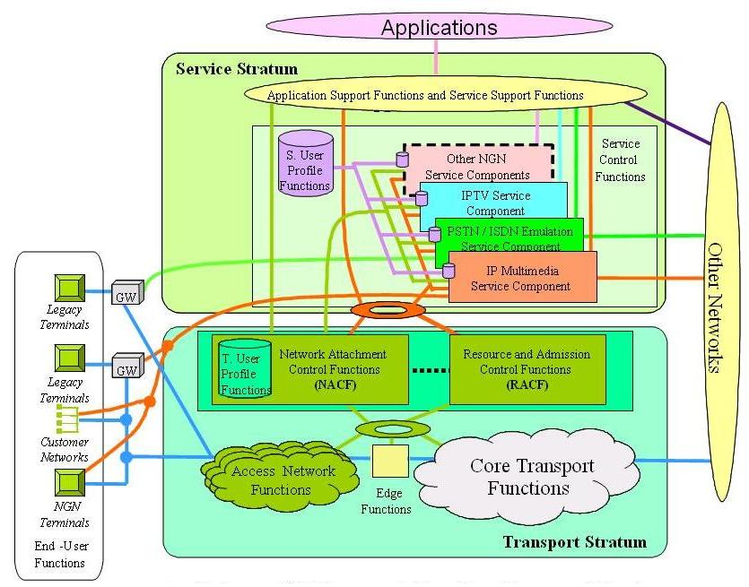
Figure I-1. Transport and service configuration of the NGN

2. Relationship with NGN components
Figure I-2 describes relationship with each service component of NGN.
- The IP multimedia service (IMS based) component is specified further in [ITU-T Y.2021].
- The PSTN/ISDN emulation service (IMS based and call server) component is specified further in [ITU-T Y.2031].
- The IPTV service (IMS based, Non-IMS, and Non NGN) component is specified further in [ITU-T Y.1910].
- The Web service (Web service, Web based) component will be specified further in a new Recommendation. In case of Web-based, interworking with other service components will be necessary.
Figure I-2. Service components and relationships in NGN architecture
________________

