 | INTERNATIONAL TELECOMMUNICATION UNION |  |  |  | COM 13 – C 1174 – E
 | TELECOMMUNICATION  STANDARDIZATION SECTOR  STUDY PERIOD 2009-2012 |  |  | October 2011
English only
Original: English
Question(s): |  | 12/13
STUDY GROUP 13 – CONTRIBUTION 1174
Source: |  | ETRI
Title: |  | Revised Draft Recommendation Y.NGN-Web (Functional Requirements and Architecture of Web Service Component in NGN)

This contribution is the revised document of Draft Recommendation Y.NGN-Web based on the output document (TD 733 (NGN-GSI)) of NGN-GSI event held in Geneva on May 2011.

In this meeting, we would carefully review this revised text for further enhancement in order to request the consent of this document at the next meeting.

________________
Draft Recommendation Y.NGN-Web
Functional Requirements and Architecture of Web Service Component in NGN

Summary
This draft Recommendation provides functional requirements and architecture of web service component using web technologies in NGN. For this, this draft Recommendation describes requirements and functional architecture of web service component in NGN.
Keywords
NGN, Web

Contents
1. Scope 4
2. References 4
3. Definitions 5
3.1 Terms defined elsewhere: 5
3.2 Terms defined in this Recommendation: 5
4. Abbreviations and acronyms 5
5. Conventions 6
6. Requirements for web service in NGN 7
7. High-level service control architecture for web 8
7.1 Web service component 8
7.2 NGN architecture with web service component 8
7.3 Services classification using web service component 9
8. Interactions with web service component 10
8.1 Interactions for the support of legacy Internet services 10
8.2 Interactions for the support of web-based conversation services 11
8.3 Interactions for the support of web-based streaming services 11
9. Functional architecture 12
9.1 Functional entities for web service component 12
9.2 Web service control function (WSCF) 13
9.3 Web media function (WMF) 13
10. Security considerations 14
Appendix I NGN service specific components in NGN architecture 15
Appendix II Relationship with functions defined in ITU-T Recommendations 18
Appendix III Information flows for services using web service component in NGN 23

Draft Recommendation Y.NGN-Web
Functional Requirements and Architecture of Web Service Component in NGN

1. Scope
The objective of this draft recommendation is to describe functional requirements and architecture of web service component in NGN using web technologies such as HTML, HTTP, XML, SOAP, REST and so on. The web service component in NGN basically supports legacy Internet services such as web-browsing, e-mail, blogging, web-office services and etc., and converged NGN services such as web-based conversational services using IP multimedia service component and web-based multimedia streaming service using IPTV services component.
The scope of this draft Recommendation includes:
- Requirements for web service in NGN;
- Web service component in the support of legacy Internet services and converged NGN services;
- Functional architecture for web service component in NGN.
This draft Recommendation mainly focuses on service control functions in service stratum of NGN. Detailed web technologies are out of scope.

2. References
The following ITU-T Recommendations and other references contain provisions, which, through reference in this text, constitute provisions of this Recommendation. At the time of publication, the editions indicated were valid. All Recommendations and other references are subject to revision; users of this Recommendation are therefore encouraged to investigate the possibility of applying the most recent edition of the Recommendations and other references listed below. A list of the currently valid ITU-T Recommendations is regularly published.
The reference to a document within this Recommendation does not give it, as a stand-alone document, the status of a Recommendation.
[ITU-T Y.101] ITU-T Recommendation Y.101 (2000), Global Information Infrastructure terminology: Terms and definitions
[ITU-T Y.1901] ITU-T Recommendation Y.1901 (2009), Requirements for the support of IPTV services
[ITU-T Y.1910] ITU-T Recommendation Y.1910 (2008), IPTV functional architecture
[ITU-T Y.2007] ITU-T Recommendation Y.2007 (2010), NGN capability Set 2
[ITU-T Y.2011] ITU-T Recommendation Y.2011 (2004), General principles and general reference model for Next Generation Networks
[ITU-T Y.2012] ITU-T Recommendation Y.2012 (2010), Functional requirements and architecture of next generation networks
[ITU-T Y.2021] ITU-T Recommendation Y.2021 (2006), IMS for Next Generation Networks
[ITU-T Y.2031] ITU-T Recommendation Y.2031 (2006), PSTN/ISDN emulation architecture
[ITU-T Y.2091] ITU-T Recommendation Y.2091 (2008), Terms and definitions for Next Generation Networks
[ITU-T Y.2201] ITU-T Recommendation Y.2201 (2009), Requirements and capabilities for ITU-T NGN
[ITU-T Y.2235] ITU-T Recommendation Y.2235 (2008), Converged web-browsing service scenarios in NGN

3. Definitions

3.1 Terms defined elsewhere:
This Recommendation uses the following terms defined elsewhere:
3.1.1 application [ITU-T Y.101]: A structured set of capabilities, which provide value-added functionality supported by one or more services.
3.1.2 functional entity [ITU-T Y.2012]: An entity that comprises an indivisible set of specific functions. Functional entities are logical concepts, while groupings of functional entities are used to describe practical, physical implementations.
3.1.3 functional architecture [ITU-T Y.2012]: A set of functional entities and the reference points between them used to describe the structure of an NGN. These functional entities are separated by reference points, and thus, they define the distribution of functions.
3.1.4 IPTV [ITU-T Y.1901]: Multimedia services such as television/video/ audio/text/graphics/data delivered over IP-based networks managed to support the required level of QoS/QoE, security, interactivity and reliability.
3.1.5 NGN service stratum [ITU-T Y.2011]: That part of the NGN which provides the user functions that transfer service-related data and the functions that control and manage service resources and network services to enable user services and applications (see also 7.1 [ITU-T Y.2011]).
3.1.6 NGN transport stratum [ITU-T Y.2011]: That part of the NGN which provides the user functions that transfer data and the functions that control and manage transport resources to carry such data between terminating entities (see also 7.1 [ITU-T Y.2011]).
3.1.7 service [ITU-T Y.2091]: A set of functions and facilities offered to a user by a provider.

3.2 Terms defined in this Recommendation:
This Recommendation defines the following terms:
3.2.1 converged NGN service: A kind of interworking services with web and NGN such as web-based conversational service using IP multimedia service component and streaming service using IPTV service component.
3.2.2 legacy Internet service: A kind of well-known Internet services such as FTP, Telnet, web-browsing, e-mail, blogging, web-office services and etc.
3.2.3 web service component: One of NGN service components in NGN service stratum together with IP multimedia service component, IPTV service component and, it enables NGN services to support legacy Internet services and converged NGN services.

4. Abbreviations and acronyms
This Recommendation uses the following abbreviations and acronyms:
API Application Programming Interface
CSCF Call Session Control Function
FTP File Transfer Protocol
HTML Hyper Text Markup Language
HTTP Hyper Text Transfer Protocol
IMS IP Multimedia Subsystem
ISDN Integrated Service Digital Network
MMoIP Multimedia over IP
NACF Network Attachment Control Function
PC Personal Computer
PCC-FE Policy and Charging Control - Functional Entity
PDA Personal Digital Assistant
PDF Policy Decision Function
PSTN Public Switched Telephone Network
PWC-FE Proxy Web Control - Functional Entity
QoS Quality of Service
RACF Resource Admission Control Function
REST Representational State Transfer
RTSP Real Time Streaming Protocol
SCIM Smart Common Input Method
SIP Session Initiation Protocol
SOAP Simple Object Access Protocol
VoIP Voice over IP
WMF Web Media Function
WMGC-FE Web Media Gateway Control - Functional Entity
WMRC-FE Web Media Resources Control - Functional Entity
WMT-FE Web Media Transform - Functional Entity
WSCF Web Service Control Function
WSDL Web Service Definition Language
WSGC-FE Web Signaling Gateway Control - Functional Entity
XML Extensible Markup Language

5. Conventions
In this Recommendation:
The keywords "is required to" indicate a requirement which must be strictly followed and from which no deviation is permitted, if conformance to this Recommendation is to be claimed.
The keywords "is prohibited from" indicate a requirement which must be strictly followed and from which no deviation is permitted, if conformance to this Recommendation is to be claimed.
The keywords "is recommended" indicate a requirement which is recommended but which is not absolutely required. Thus, this requirement need not be present to claim conformance.
The keywords "is not recommended" indicate a requirement which is not recommended but which is not specifically prohibited. Thus, conformance with this Recommendation can still be claimed even if this requirement is present.
The keywords "can optionally" indicate an optional requirement which is permissible, without implying any sense of being recommended. This term is not intended to imply that the vendor's implementation must provide the option, and the feature can be optionally enabled by the network operator/service provider. Rather, it means the vendor may optionally provide the feature and still claim conformance with this Recommendation.

6. Requirements for web service in NGN

The NGN has the following general requirements to support web related applications/services.
- It is required to provide ‘web-based application support’ satisfying with interoperability across wired and wireless network environment;
The web-based application support enablers allow enhanced utilization of device capabilities and network characteristics for web-based applications [ITU-T Y.2201].
Web-based application support capabilities provide users with a consistent web environment which spans multiple network environments and multiple devices (PC, laptop, smart phone, etc.) [ITU-T Y.2201].
- It is required to support web-based information and media types including text, audio, image, video and related metadata formats.
- It is required to provide the service control functions such as service directory, classification, session management, protocol mapping, billing & charging and etc. on the web.
- It is required to provide the media transformation functions such as transcoding, filtering, QoS control and media gateway and etc. on the web.
- It is required to support the interaction with existing NGN services & transport control functions such as user profile function in service stratum and RACF, NACF in transport stratum and so on.

The NGN is required to support various types of services using web as follows.
- It is required to support legacy Internet services in NGN environment.
A number of well-known Internet services are required to be supported in NGN, for instance web-browsing, e-mail, blogging, web-office services and etc. using web technologies.
- It is required to support interworking with conversation services using web
NOTE - The service capability interaction manager (SCIM) and Parlay Gateway could be used for conversation services.
NOTE – A protocol interworking between HTTP and SIP is necessary to support Web-based IMS service.
- It is required to support interworking with streaming services using web
NOTE - The IPTV media delivery could be used for streaming services.

7. High-level service control architecture for web

7.1 Web service component
NGN architecture has three service components for service control function: IPTV service component, PSTN/ISDN emulation service component, and IP multimedia service component. Additionally a web service component is newly added into service stratum of NGN architecture to support web related capabilities as shown in Figure 1.
The web service component enables NGN services to support legacy Internet services and converged NGN services. For this, the web service component supports the web standard interfaces and protocols such as HTML, XML, HTTP, SOAP, REST, WSDL and so on.

Figure 1.Web service component in NGN service specific components

7.2 NGN architecture with web service component
The Figure 2 shows NGN-Web convergence architectural model for interconnecting NGN and web. The architecture mainly comprises web service control function (WSCF) and web media function (WMF). The WSCF performs adaptation function between the NGN service stratum and the web. The WMF performs interworking between the NGN transport stratum and the web.
In Figure 2, the service components are related to each other and may contain common or shared functionality.

Figure 2. NGN architecture with web service component

7.3 Services classification using web service component
NGN should support multi-service capabilities which support various composition services simultaneously. The network requires networking environment with NGN/web convergence.
According to different service control, web service in NGN can be classified as follows.
- Legacy Internet services (Pure Web Services): A kind of well-known Internet services using web in NGN environment such as web-browsing, e-mail, blogging, web-office services and etc.
- Converged NGN services: A kind of interworking services with web and NGN
  - Web-based IMS services (e.g., MMoIP using web)
    - Web-based IMS services using interworking with IP multimedia service component
  - Web-based streaming services (e.g., IPTV using web)
    - Web-based streaming services using interworking with IPTV service component
  - Web-based composition services (e.g., MMoIP + IPTV using web)
    - Composition services both web service component and interworking with other service components
Figure 3 depicts related service components for various kinds of web service in NGN. Web service component interacts with IPTV service component as well as IP multimedia service component for converged NGN services. Common functionalities are a group of functional entities which are specified in other service component.

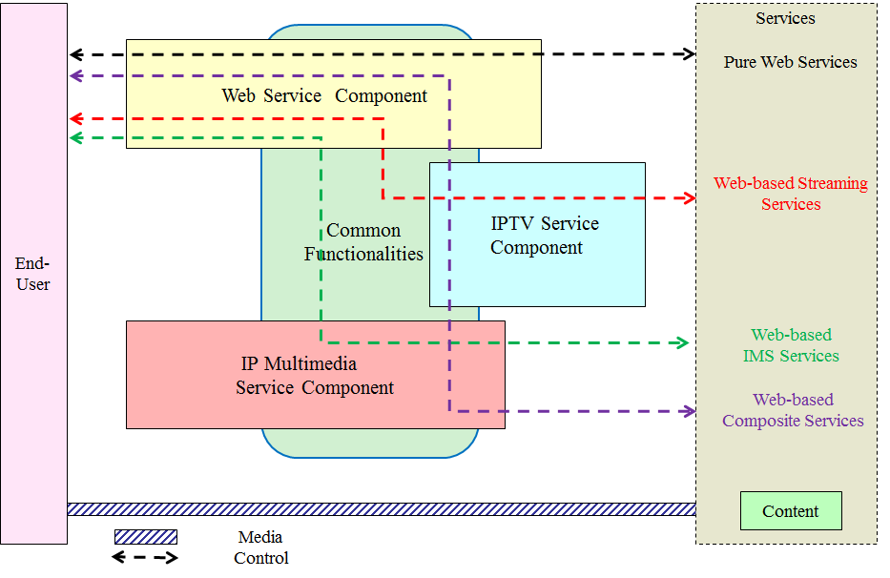
Figure 3. Service classification according to different service control

Appendix IV describes common component and functionalities related to web service component in detail.

8. Interactions with web service component
This section introduces the interactions among relevant functions to provide web services as well as web based services.

8.1 Interactions for the support of legacy Internet services
End user requests an Internet service to web service control functions, utilizing HTTP protocol to communicate with web server. At next, web service control functions determine an appropriate web server to provide the request service with directory by referring service user profile functions. The web server makes an Internet service by transferring service response message to end user. At this time, web media functions can transcode the media data in web page into an appropriate format to end user’s device, if the web server cannot support the requested format from end user.
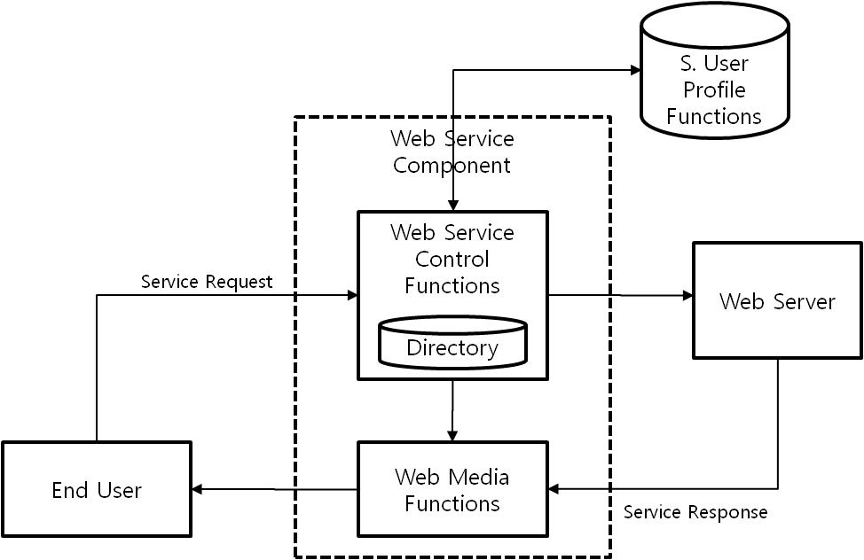
Figure 4. Legacy Internet services using web service component

8.2 Interactions for the support of web-based conversation services
End user requests a conversation service to web service control functions, utilizing HTTP protocol to communicate with IP multimedia service component. IP multimedia service component makes a conversation service by a method of calling relevant APIs to interact with IMS call server and then responds to the service request from end user. At this time, web media functions can transcode the media data into an appropriate format to end user, if IMS call server cannot support the requested codec from end user.
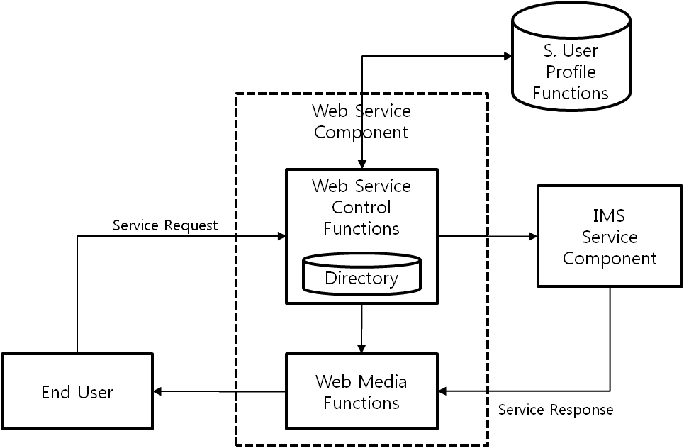
Figure 5. Web-based conversation services using web service component

8.3 Interactions for the support of web-based streaming services
End user requests a streaming service to web service control functions, utilizing HTTP protocol to communicate with IPTV service component. IPTV service component makes a streaming service by delivering video streaming to end user. At this time, web media functions can transcode the media data into an appropriate format to end user, if IPTV service component cannot support the requested video streaming format from end user.
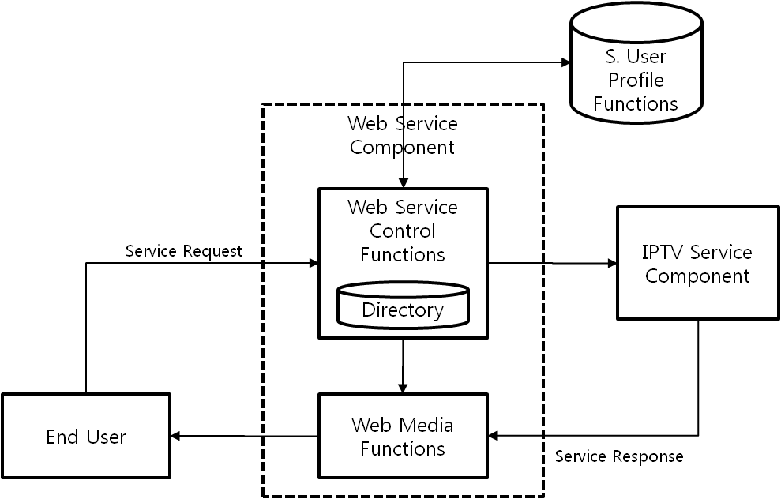
Figure 6. Web-based streaming services using web service component

9. Functional architecture

9.1 Functional entities for web service component

Figure 7.Functional entities for web service component in NGN
Web service component is comprised of the following functional entities:
Web service control functions include:
- PWC-FE (Proxy Web Control - Functional Entity): PWC-FE performs functionalities as proxy between web server and HTTP client through interaction with directory including profile information.
- WSGC-FE (Web Signaling Gateway Control - Functional Entity): WSGC-FE performs functionalities of signalling gateway and session manager.
- PCC-FE (Policy and Charging Control - Functional Entity): PCC-FE instruct PEC-FE and get information of session flow or service usage from PEC-FE at the transport control functions
- WMRC-FE (Web Media Resources Control - Functional Entity): WMRC-FE is in charge of providing controlling resources to the users.
Web media functions include:
- WMGC-FE (Web Media Gateway Control - Functional Entity): WMGC-FE is controlled by the WSGC-FE in order to allow authorized media flow.
- WMT-FE (Web Media Transform - Functional Entity): WMT-FE performs media adaptation according to different user devices and transport environments.
(Editor’s Note) Detailed descriptions for each functional entity will be added for further progress. Interactions with transport control functions such as NACF, MMCF, and RACF should be indicated in the figure. The clear distinction of similar functions in service stratum and transport stratum are also required.

9.2 Web service control function (WSCF)
Key capabilities for WSCF
- Service directory: it holds a list of peer web server
- Service classification: it identities service types for appropriate service control
- Signaling mapping and translation (adaptation function): it performs protocol conversion (e.g., between HTTP and SIP)
- Session manager: it performs session management with session control functions
- Billing & Charging: it performs traffic measurement/monitoring
- Use of Web interfaces: It is used for searching and discovery through the query to directory/repository
Interactions with other components for WSCF
- NGN service control functions: PDF, CSCF, profile management
- Web media function: media delivery and conversion (gateway functions)
- Web components: interface with web server and web service description languages, and support of personalization, social networking using mesh-up, semantic, and ontology, etc
- Service platform: service creation, service composition
- 3rd party applications: open API

9.3 Web media function (WMF)
Key capabilities for WMF
- Transcoding: conversion between different codecs
- Packet filtering: depending on IP addresses and port numbers
- QoS control: resource allocation and management, policing based on media flow parameters (e.g., packet size, bandwidth limits, etc)
- Media gateway: media delivery and conversion as well as transport interworking between NGN and Web

Interactions with other components for WMF
- NGN transport control functions: interaction with RACF and NACF
- Web server: interface with media transport protocol (e.g., RTSP, etc)

10. Security considerations
(TBD)

Appendix I
NGN service specific components in NGN architecture
(This appendix does not form an integral part of this Recommendation)

1. Current NGN service specific components
This section introduces the concept of current NGN service specific components, derived from the generalized NGN functional architecture based on [ITU-T Y.2012] and [ITU-T Y.1910]. (see Figure I-1)
- IP multimedia service component
The IP multimedia service component supports mediated multimedia services. These services may include multimedia session services, such as voice or video telephony or PSTN/ISDN simulation, and some non-session services, such as subscribe/notify for presence information and the message method for message exchange.
- PSTN/ISDN emulation service component
The PSTN/ISDN emulation service component enables the support of legacy terminals connected through a gateway to an IP network. All PSTN/ISDN services remain available and identical (i.e., with the same operating characteristics), such that end users are unaware that they are not connected to a TDM-based PSTN/ISDN. Not all service capabilities and interfaces have to be present to provide PSTN/ISDN emulation.
- IPTV service component
Service control functions and content delivery functions can optionally be included in the IPTV service component of NGN. Thus, application functions, service control functions, and content delivery functions are included in the service stratum of the NGN architecture. IPTV service control functional block corresponds to NGN service control functions. However, NGN service control functions can optionally include other functionalities.
Figure I-1. Transport and service configuration of the NGN
2. Relationship with NGN components
Figure I-2 describes relationship with each service component of NGN.
- The IP multimedia service (IMS based) component is specified further in [ITU-T Y.2021].
- The PSTN/ISDN emulation service (IMS based and call server) component is specified further in [ITU-T Y.2031].
- The IPTV service (IMS based, Non-IMS, and Non NGN) component is specified further in [ITU-T Y.1910].
- The web service component will be specified in this Recommendation. In case of Web-based, interworking with other service components will be necessary.
Figure I-2. Service components and relationships in NGN architecture

Appendix II
Relationship with functions defined in ITU-T Recommendations
(This appendix does not form an integral part of this Recommendation)
The appendix provides mapping information of related functions between Y.NGN-Web and other Recommendations.

1. Relationship between Y.2235 and Y.NGN-Web
The Table II-1 show mapping of related functions between Y.2235 and Y.NGN-Web.

Table II-1 Mapping between Y.2235 and Y.NGN-WeB
ITU-T Recommendation Y.2235 | ITU-T Draft Recommendation Y.NGN-Web
Functional entities | Corresponding functional entities
Web Proxy Function | PWC-FE
Profile Serving Function | Directory
Content Transformation Function | WMT-FE

2. Related functions for web service in NGN
Authentication Aspect
The following FE could be used for authenticating and authorizing service access of IMS, IPTV, and Web, simultaneously.
- Service authentication and authorization functional entity (SAA-FE): It provides authentication and authorization in the service stratum.
- Subscription locator functional entity (SL-FE): It is used to find the address of the physical entity that holds the subscriber data for a given user identifier when multiple, separately addressable SUP-FEs have been deployed by the NGN operator.
- Service user profile functional entity (SUP-FE): It is responsible for storing user profiles, device profiles, subscriber-related location data, and presence status data in the Service stratum. A user profile is a set of stored information related to authentication, authorization, mobility, location, charging, etc. A device profile is a set of stored information related to the terminal (e.g., screen size, supported media, etc.).

Interworking Aspect
The following FE could be used for protocol interworking between HTTP and RTSP, SIP and HTTP, etc.
- User signalling interworking functional entity (USIW-FE): It has the responsibility for the interworking and information screening functions for different types of application signalling at the subscriber side. It is assumed that protocol interworking happens, for example between HTTP and SIP, in this functional entity.
- Network signalling interworking functional entity (NSIW-FE): It has the responsibility for the interworking for different types and profiles of application signalling at the trunking side. It is assumed that protocol interworking happens, for example between HTTP and SIP, in this functional entity.

Media Control Aspect
The following FE could be used for controlling media adaptation of audio, video, and web page, etc.
- Media resource control functional entity (MRC-FE): It controls the media resource processing functional entity (MRP-FE) by operating as a media resource control function. It should be used for enabling MRP-EF to transform the web content into an appropriate form according to the profile information
- Media resource broker functional entity (MRB-FE): It assigns specific media server resources (i.e., MRC-FE and MRP-FE) to incoming calls at the request of service applications.

Application Aspect
The following FE could be used for blending service features and making new converged services between IMS, IPTV, and Web service component.
- Application support functional entity (AS-FE): It supports generic application server functions including hosting and executing services.
- Application gateway functional entity (APL-GW-FE): It serves as an interworking entity between the applications and the S-CSC-FE of the service stratum.
- Application service coordination manager functional entity (APL-SCM-FE): It manages interactions between multiple applications and services. It should be used for providing the Web-based composite services.

3. Common functionalities
(Editor’s Note) Further discussion on the necessity of the following diagram is needed.
In Figure IV-1, there are 6 cases among different service components.
- Case 1: Web service component
- Case 2: Web service component + IPTV service component
- Case 3: Web service component + IP multimedia service component + IPTV service component
- Case 4: Web service component + IP multimedia service component
- Case 5: Web service component + IP multimedia service component + PSTN/ISDN service component
- Case 6: Web service component + PSTN/ISDN service component

Figure IV-1. Common functionalities according to different service control

(Editor’s Note) In the meeting, there was a discussion on PSTN/ISDN service component. Further clarification for the necessity of interworking with PSTN/ISDN service component is required. If this component does not require, Figure IV-1 should be modified.
(Editor’s Note) The following appendix was the introduction to describe the necessity of new work item on web service component. As this document is a final stage, we propose to delete the Appendix III.

(Editor’s Note) We propose to merge the Appendix IV into the Appendix II with minor modifications.

Appendix III
Information flows for services using web service component in NGN
(This appendix does not form an integral part of this Recommendation)

1. Procedure for the support of legacy Internet services
The information flow for legacy Internet service using web service component with directory including profile information is shown in Figure III-1.

Figure III-1. The message flow for Legacy Internet service using web service component

The information flow is:
- End user requests the Internet service to get web contents utilizing HTTP protocol;
- Web service component, especially PWC-FE refers to directory to get a list of peer web server;
- PWC-FE request profile to refer information of end user;
- Service user profile function responds with the profile of end user;
- PWC-FE determines a web server and requests Internet service to WSGC-FE with user profile;
- WSGC-FE requests Internet service to the web server;
- Web server responds with the requested web contents to WSGC-FE;
- If the web server cannot support the requested format according to user profile, WSGC-FE requests web contents transformation to WMT-FE through WMGC-FE;
- WMT-FE transcodes web contents into an appropriate format to end user’s device and responds them to the WSGC-FE;
- WSGC-FE responds with formatted web contents to PWC-FE; and
- PWC-FE responds to end user.
2. Procedure for the support of web-based conversation services
The information flow for conversation service using web service component with directory including profile information is shown in Figure III-2.

Figure III-2. The message flows for web-based conversation services using web service component
The information flow is:
- End user requests the conversation service to web service component, utilizing HTTP protocol in order to communicate with IP multimedia service component that interacts with IMS call server;
- Web service component, especially PWC-FE refers to directory to get a list of peer IMS call server;
- PWC-FE requests profile to get information of end user;
- Service user profile function responds with the profile of end user;
- PWC-FE determines an IMS call server and requests conversation service to WSGC-FE with user profile.
- WSGC-FE converts protocol HTTP into SIP and requests conversation service to IMS service component.;
- IP multimedia service component makes a conversation service by calling relevant APIs with IMS call server and responds to WSGC-FE. Also WSGC-FE convert protocol SIP into HTTP;
- If the IMS call server cannot support the requested codec according to user profile, WSGC-FE requests transformation of conversational contents to WMT-FE through WMGC-FE;
- WMT-FE transcodes contents into an appropriate format to end user’s device and responds them to the WSGC-FE;
- WSGC-FE responds with formatted conversational contents to PWC-FE; and
- PWC-FE responds to end user.

3. Procedure for the support of web-based streaming services
The information flow for web-based streaming service using web service component with directory including profile information is shown in Figure III-3.

Figure III-3. The message flows for web-based streaming services using web service component

The information flow is:
- End user requests the streaming service to web service component, utilizing HTTP protocol in order to receive video streaming contents;
- Web service component, especially PWC-FE refers to directory to get a list of peer streaming server;
- PWC-FE requests profile to refer information of end user;
- Service user profile function responds with the profile of end user;
- PWC-FE determines a streaming server and requests streaming service to WSGC-FE with user profile.
- If the streaming server cannot support HTTP protocol, WSGC-FE converts protocol HTTP into an appropriate protocol and requests streaming service to IPTV service component;
- IPTV service component makes a streaming service with streaming server and responds to WSGC-FE. Also WSGE-FE convert protocol into HTTP;
- If the streaming server cannot support the requested codec according to user profile, WSGC-FE requests transformation of streaming contents to WMT-FE through WMGC-FE;
- WMT-FE transcodes contents into an appropriate format to end user’s device and responds them to the WSGC-FE;
- WSGC-FE responds with formatted streaming contents to PWC-FE; and
- PWC-FE responds to end user.
________________

