 | INTERNATIONAL TELECOMMUNICATION UNION |  |  |  | IPTV-GSI – C 286 – E
 | TELECOMMUNICATION  STANDARDIZATION SECTOR  STUDY PERIOD 2009-2012 |  |  | June 2009
English only
Original: English
Question(s): |  | 12/13
IPTV-GSI – CONTRIBUTION 286
Source: |  | ETRI
Title: |  | Proposal for a new web service component in NGN architecture for multi-service capabilities

1. Introduction

From service evolutional point of view, most of NGN services will be based on web technologies with user friendly and personalized solutions to support multi-service capabilities. Regarding this, the Q.12/13 has discussed Web service architecture over NGN at the last May meeting and agreed to adopt this topic as a living list item.
In NGN release 1, two components were identified in the service stratum: the IP multimedia service component and the PSTN/ISDN emulation service component. Other NGN service components were remained for the future to address other services such as streaming services. After that, IPTV service component has newly added in the service stratum for IPTV services. Similar manner, web service component will be required for supporting Web, etc.
Therefore, in this contribution, we propose a new Web service component for NGN-Web convergence to support multi-service capabilities using Web.

2. NGN service specific components in NGN architecture
2.1. Current NGN service specific components
This section introduces the concept of current NGN service specific components, derived from the generalized NGN functional architecture based on [ITU-T Y.2012] and [ITU-T Y.1910]. (see Figure 1)
- IP multimedia service component
The IP multimedia service component supports mediated multimedia services. These services may include multimedia session services, such as voice or video telephony or PSTN/ISDN simulation, and some non-session services, such as subscribe/notify for presence information and the message method for message exchange.
- PSTN/ISDN emulation service component
The PSTN/ISDN emulation service component enables the support of legacy terminals connected through a gateway to an IP network. All PSTN/ISDN services remain available and identical (i.e., with the same operating characteristics), such that end users are unaware that they are not connected to a TDM-based PSTN/ISDN. Not all service capabilities and interfaces have to be present to provide PSTN/ISDN emulation.
- IPTV service component
Service control functions and content delivery functions can optionally be included in the IPTV service component of NGN. Thus, application functions, service control functions, and content delivery functions are included in the service stratum of the NGN architecture. IPTV service control functional block corresponds to NGN service control functions. However, NGN service control functions can optionally include other functionalities.

2.2. Web service component
In order to support web-related services, this contribution proposes a new Web service component as shown in Figure 1.

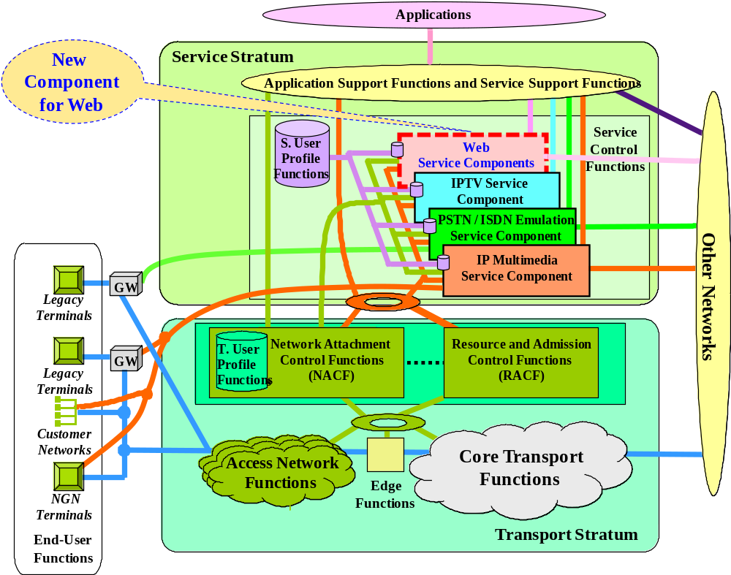
Figure 1.Web service component in NGN service specific components

- Web service component
The Web service component enables web service and web based service. For Web service, this component supports Web technologies such as HTTP, SOAP(Simple Object Access Protocol), XML(Extensible Markup Language), and WSDL(Web Services Description Language), etc. Other service components can use the Web service component to support various applications using Web.

2.3. Relationship with NGN components
Figure 2 describes relationship with each service component of NGN.
- The IP multimedia service (IMS based) component is specified further in [ITU-T Y.2021].
- The PSTN/ISDN emulation service (IMS based and call server) component is specified further in [ITU-T Y.2031].
- The IPTV service (IMS based, Non-IMS, and Non NGN) component is specified further in [ITU-T Y.1910].
- The Web service (Web service, Web based) component will be specified further in a new Recommendation. In case of Web-based, interworking with other service components will be necessary.

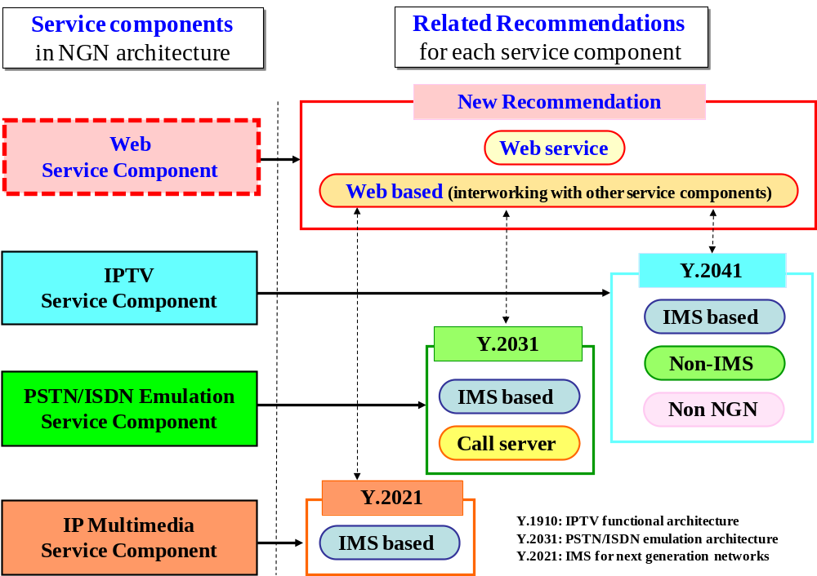
Figure 2. Service components and relationships in NGN architecture

3. Proposal

We would like to discuss the proposed Web service component in NGN architecture and also request to include our proposal (the Section 2) in the Appendix of current living list (Web service architecture over NGN) of Q.12/13 for encouraging contributions and developing an initial draft recommendation on this work.
________________

